**Input:**

F(x): x3 – 3x + 1

X0 = 0

X1 = 1

EPS = 0.0001

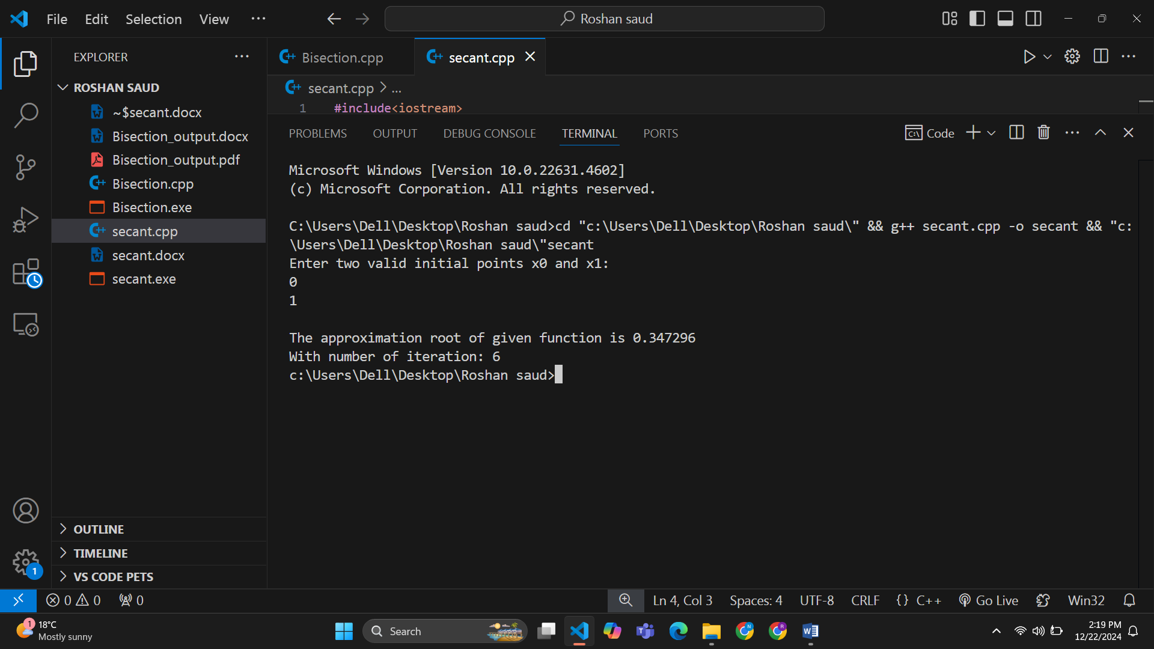**Output:**

**Input:**

F(x): 3x + sin(x) - ex

X0 = 0

X1 = 1

EPS = 0.00001

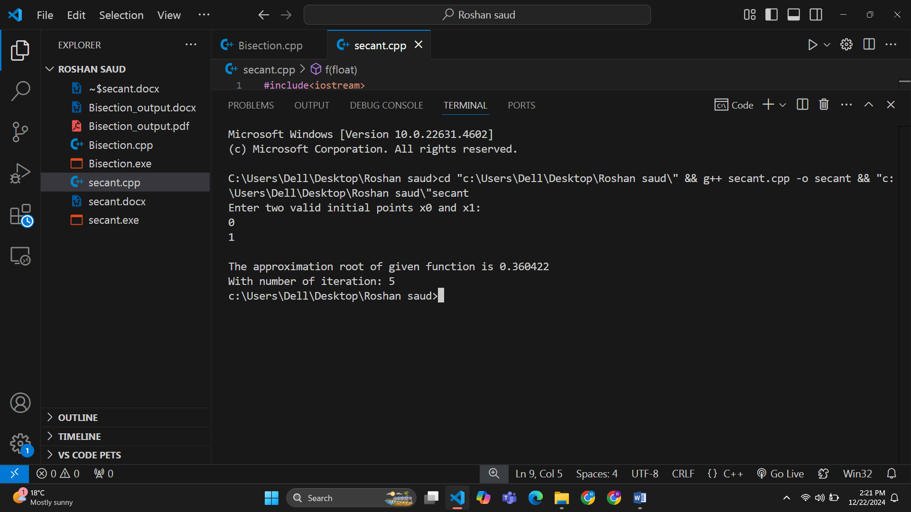**Output:**